ACKNOWLEDGEMENT

This report would not have been published without the guidance and assistance of several people who always provide a good solution and extended their valuable assistance in preparing and implementing this project.

First of all, I would like to express our deepest gratitude to **Dr. PO Kimtho**,director of the Institute of Technology of Cambodia, for his good cooperation with the partner universities at the local, regional, and international levels, to enhance the quality of the training of engineers and senior technicians.

Secondly, I would like to thank **MR. LAY Heng**, Head Department of Information Communication Engineering, for his management, vision, and efficient policy to develop a better quality of education in the department and his guidance to efficiently finish the thesis.

Thirdly, I would also like to acknowledge **Mr. SOK Kimheng**, my internship supervisor and project management supervisor, for the time he has devoted to me during this period for giving the solutions, ideas, and technical. I also greet him for his remarks and corrections which allow me to write our final dissertation.

Very special thanks to all teachers in the Information of Communication Engineering department for the knowledge they have given me plenty of value.

Finally, I would like to express my profound gratitude to my parents for their unfailing support and continuous encouragement in my life to successfully achieve my higher study. It could not have been possible without them.

មូលន័យសង្ខេប

ក្នុងអំឡុងកពេលធ្វើកម្មសិក្សារយះពេល៣ខែ បន្ទាប់ពីបានបញ្ចប់ការសិក្សាឆ្នាំទី៥របស់ខ្ញុំនៅវិទ្យាស្ថានបច្ចេកវិទ្យាកម្ពុជា គ្រប់សិស្សានុសិស្សទាំងអស់រួមទាំងខ្ញុំផងដែរគឺមានកាតព្វកិច្ចត្រូវចុះកម្មសិក្សាក្នុងគោលបំណងធ្វើការអនុត្តជាក់ស្តែងនូវអ្វីដែលខ្ញុំបានសិក្សានៅសាលាកន្លងមក។ របាយការណ៍នេះបានផ្តល់ឱ្យមាននូវព័ត៍មានលំអិតនៃការ​ចុះកម្មសិក្សារបស់ខ្ញុំនៅវិទ្យាស្ថានបច្ចេកវិទ្យាកម្ពុជា ៣ខែ ដែលបានធ្វើឡើងចាប់ពីថ្ងៃទី​ ១៣​ ខែកុម្ភះ ឆ្នាំ២០២២ ដល់ថ្ងៃទី ១៣​ ខែឧសភា ឆ្នាំ២០២៣។​​ ប្រធានបទកម្មសិក្សារបស់ខ្ញុំគឺ **ប្រព័ន្ធគ្រប់គ្រងបណ្ណាល័យ** ដែលជាប្រព័ន្ធមួយសំខាន់ ដែលប្រើនៅក្នុងសាលាដែលបានបង្កើតឡើងក្នុងគោលបំណងដើម្បីផ្តល់នូវគេហទំព័រមួយសម្រាប់ការគ្រប់គ្រង់ដំណើរការចុះឈ្មោះសិស្សនិសិ្សតដែលចូលបណ្ណាល័យ។

**ប្រព័ន្ធគ្រប់គ្រងបណ្ណាល័យ ​**គឺជាគេហទំព័រមួយដែលត្រូវបានបង្កើតឡើងក្នុងគោលបំណងផ្តល់នូវមុខងារសំខាន់ៗ ដែលអនុញ្ញាតិឱ្យអ្នកប្រើប្រាស់អាចគ្រប់គ្រង់ទិន្នន័យបេក្ខជនទាំងអស់ដោយសំរួលការរក្សារទុក្ខជាក្រដាស។ មួយវិញទៀតអ្នកប្រើប្រាស់អាចត្រួតពិនិត្យការចុះឈ្មោះរបស់និសិត្សជាប្រចាំថ្ងៃ និងអាចធ្វើការទាញយកទិន្នន័យសិស្សនិសិ្សតជារបាយការណ៍ និងក្រាហ្វ។ មិនត្រឹមតែប៉ុណ្ណោះអ្នកប្រើប្រាស់អាចធ្វើការរក្សាទុក្ខព័ត៌មានសៀវភៅទៅតាមទីកន្លែង និងតាមដេប៉ាតឺម៉ង់បានផងដែល។ លើសពីនេះក៏អាចបញ្ចូលទិន្នន័យជាឯកសារ Excel បានផងដែរ។

គម្រោងនៃកម្មវិធីគេហទំព័រមួយនេះត្រូវបាយអនុវត្តនៅក្នុងភាសាសរសេរកម្មវិធី Node JS ដោយប្រើប្រាស់ហ្វ្រេមវើក (Framework) Express JS។ សម្រាប់ការគ្រប់គ្រងទិន្នន័យនៃប្រព័ន្ធនេះត្រូវបានអនុវត្តជាមួយ MYSQL និង សម្រាប់ខាងផ្នែកការបង្ហាញទៅកាន់អ្នកប្រើប្រាស់ត្រូវបានអនុវត្តជាមួយ Vue JS។

ជាលិទ្ធផលនៃការចុះកម្មសិក្សា បច្ចុប្បន្ននេះគឺស្ថិតក្នុងការអភិវឌ្ឍន៍បន្ថែមដើម្បីអោយកាន់តែប្រសើរជាងមុន។ ហើយគេហទំព័រនិងដាក់ប្រើប្រាស់ជាផ្លូវការក្នុងបណ្ណាល័យឆាប់ៗខាងមុខនេះ។

RÉSUMÉ

Pendant le stage de trois mois qui a suivi la fin de ma cinquième année universitaire à l'Institut de technologie du Cambodge. Tous les étudiants du département d'ingénierie de l'information, de la technologie et de la communication et moi-même avons été obligés de faire un stage pour mettre en pratique ce que j'ai appris à l'école. Ce rapport détaille le stage qui s'est déroulé entre le 13 février et le 11 mai 2023 à l'Institut de Technologie du Cambodge. Le projet durant le stage concerne le "Library Management System" dont l'objet est de fournir une plateforme d'application web pour contrôler les informations des candidats et leur présence lorsqu'ils rejoignent la bibliothèque de la tige.

Le système est un projet d'application web développé pour fournir des fonctions utiles aux utilisateurs afin de gérer toutes les informations sur les étudiants et leur présence lorsqu'ils rejoignent la bibliothèque. Une autre fonction permet aux utilisateurs de suivre les données des étudiants chaque jour et de télécharger les informations sous forme de graphiques et de fichiers CSV. En outre, les utilisateurs peuvent stocker des informations sur les livres en fonction de leur localisation et de leur département. L'une des principales fonctions du système consiste à télécharger des informations sur les étudiants à partir d'un fichier Excel.

Ce projet de plateforme web est mis en œuvre à l'aide du framework Express JS en langage Node JS. La base de données du système est implémentée avec MYSQL et Vue JS est implémenté du côté client.

À la suite de ce stage, le système est actuellement en cours d'amélioration. Le système sera bientôt officiellement lancé à la bibliothèque Stem.

ABSTRACT

During the three-month internship after ending my fifth academic year at the Institute of Technology of Cambodia. All students of the Department of Information of Technology and Communication Engineering and I were obliged to undergo an internship to apply what I have learned in school into practice. This report drives into detail of internship which took place between 13 February and 11 May 2023 at the Institute of Technology of Cambodia. The project during the internship concerns the “**Library Management System**” whose object is to provide a web application platform for controlling the candidate information and candidate attendance when they join the stem library.

The system is a web application project developed to provide useful features for users to manage all student information and attendance when joining the library. Another feature allows users to monitor student data each day and download the information as graphs and CSV files. Additionally, users can store book information related to their location and department. One of the main functions of the system is to upload student information from an Excel file.

This web platform project is implemented using the Express JS framework in Node JS language. The system's database is implemented with MYSQL and Vue JS is implemented on the client side.

As a result of this internship, it is current it is currently being further developed for the better. And for the system will be officially launched in the Stem library soon.

LIST OF ABBREVIATION

UI: User Interface

MVC: Model View Controller

UML: Unified Modeling Language

URL: Uniform Modeling Language

IDE: Integrated Development Environment

SQL: Structure Query Language

CSS: Cascading Style Sheets

HTML: Hypertext Markup Language

ERD: Entity Relation Diagram

OPA: Open Policy Agent

LIST OF FIGURES AND TABLE

Figure 1: ITC Logo 1

Figure 2: ITC Location 2

Figure **3**: Waterfall Methodology 4

*Figure 4:Use case diagram Library Management System* 8

*Figure 5: The database schema* 9

Figure 6: Activity diagram of adding new user 10

Figure 7: Activity diagram of adding new candidate 11

Figure 8: Activity diagram for register attendance 12

Figure 9: Activity diagram add book to department 13

Figure 10: Physical architecture of application 14

Figure 11: Logical architecture of application 15

Figure 12: Node JS logo 16

Figure 13: HTML, CSS, and Javascript 16

Figure 14: Vue JS logo 16

Figure 15: Vuetify logo 17

Figure 16: MYSQL logo 17

Figure 17: GitHub logo 18

Figure 18: InterlliJ logo 18

Figure 19: VS code logo 18

Figure 20: Postman logo 19

Figure 21: XAMPP control panel logo 19

Figure 22: Heidi SQL logo 19

Figure 23: Node JS initial project 20

Figure 24: Vue creates an application 21

Figure 25: Node JS project structure 21

Figure 26: Vue JS project structure 23

Figure 27: Login authentication flowchart 24

Figure 28: Create a candidate flow chart 25

Figure 29: Create a book flow chart 26

Figure 30: Add books to the department flow chart 27

Figure 31: Build the Web Assembly OPA 28

Figure 32: Import student information by Excel file 29

Figure 33: Save Excel file 30

Figure 34: Option for export image 30

Figure 35: Register Page 35

Figure 37: Login page 35

Figure 36: Student Page 35

Figure 38: Home page 36

Figure 39: Create student dialog 36

Figure 40: Upload data Excel page 37

Figure 41: Generate student card page 37

Figure 42: Generate the top ten register page 37

Figure 43: Book find page 38

Figure 44: Add book to department dialog 38

Figure 45: Remove book from department dialog 38

Figure 46: Attendance report bar chart 39

Figure 47: Change the Password page 39

Figure 48: User Manager page 39

Table 1: Planning table 5

*Table 2: Project requirement table* 7

Table 3: Project result table 31

TABLE OF CONTENT

ACKNOWLEDGEMENT i

មូលន័យសង្ខេប ii

RÉSUMÉ iii

ABSTRACT iv

LIST OF ABBREVIATION v

LIST OF FIGURES AND TABLE vi

TABLE OF CONTENT viii

INTRODUCTION xi

1. GENERAL PRESENTATION OF INTERNSHIP 1

1.1 Introduction 1

1.2 Department of Information and Communication Engineering 1

1.3 Address and contact 2

2. THE INTERNSHIP PROJECT PRESENTATION 3

2.1 Structure 3

2.2 Problem overview 3

2.3 Objective 3

2.4 Software development life cycle 4

2.4.1 Waterfall 4

2.5 Planning 5

3. PROJECT ANALYSIS, CONCEPTION, AND DESIGN 6

3.1 Case study of requirement 6

3.1.1 Project requirement 6

3.1.2 Non-functional requirement 7

3.2 Project analysis 8

3.2.1 Use case diagram 8

3.2.2 Database schema 9

3.2.3 Activity diagram 9

3.2.3.1 Add new user diagram 9

3.2.3.2 Add new candidate diagram 10

3.2.3.3 Register attendance 11

3.2.3.4 Add the book to the department 12

4. TECHNOLOGY AND DESIGN 14

4.1 System and Design 14

4.1.1 Physical architecture 14

4.1.2 Logical architecture 15

4.2 Framework and Technology 16

4.3 Version control system 17

4.4 Tools 18

5. PROJECT IMPLEMENTATION 20

5.1 Project setup 20

5.1.1 Environment setup 20

5.1.2 Project initialization 20

5.1.2.1 Create a project with Node JS 20

5.1.2.2 Create Vue JS application 20

5.2 Project structure 21

5.2.1 Node JS project structure 21

5.2.2 Vue JS project structure 22

5.3 Project implement 23

5.3.1 Login authentication and logout process 23

5.3.2 Create a new candidate 25

5.3.3 Create a new book 26

5.3.4 Add multiple books and department 26

5.3.5 Access Control with Open Policy Agent 27

5.3.6 Import student information from Excel file 28

5.3.7 Export report as Excel file 29

5.3.8 Export image student card 30

6. CONCLUSION 31

6.1 Complete and uncompleted task 31

6.2 Strong point 31

6.3 Weak point 32

6.4 Difficulties 32

6.5 Experience 32

6.6 Perspective 33

6.7 Summary 33

7. REFERENCES 34

8. ANNEXES 35

INTRODUCTION

As engineering students of the Department of Information and Communication Engineering at ITC, the students are required to take an internship for thesis defending before graduation, so they can apply the knowledge that has learned from school as well as acquire new knowledge both soft and hard skill from a company, organization or somewhere else.

Technology offers us many innovations from day to day, especially smartphones, laptops, and desktops which contain modern browsers. Nowadays, there are several platforms of browser applications in the market like Google Chrome, Microsoft Edge, and Apple Safari that offered the use and develop many types of websites. Through this evolution, during my internship, I decided to develop a website application. Otherwise, I applied knowledge, I got from my adviser, about design patterns to prove the lesson theory.

The year fifth internship required students to hold an acceptable project considered by their adviser. Meanwhile, project management at STEM Library needs a system to help the administrator manage their attendance easier than usual. The system creates for managing users’ information and attendance when they do join the library. Moreover, this application is built using to manage book information related to location and department that is easy to find and put back.

As a result, a project manager has proposed a project on the Web application “Library Management System” to meet these constraints to facilitate users to manage their system in STEM Library.

This is the final internship report such a thesis divided into 7 chapters. The first is the general presentation of the internship project and information about the place where I took it to build this application. The second focuses on the internship project presentation that I work on during three months internship. Third is the analysis of project ideas, conception, and design that talk about main functional requirements and optional functional requirements. Fourth talk about technology and tool that I use. The Fifth is focused on project implementation. The last one is the conclusion.

# GENERAL PRESENTATION OF INTERNSHIP

## Introduction

The Institute of Technology of Cambodia (ITC) is a Cambodian Higher Education Institution that was founded in 1964 and supported by cooperation between Cambodia and the former Soviet Union. More than 10000 executive members have graduated from ITC. They are currently working intensely on the economic and social infrastructure development of Cambodia. In 1993, the Cambodian and French governments agreed to renovate ITC to improve the performance of the administration and financial services along with the educational system of the institution and the human resources.

The goal of ITC is to provide students with a high-quality education in the fields of engineering sciences and technologies. Students are provided with technical know-how and skills of analysis which allow integration and evolution in the labor market. To achieve this, academic and international scientific research requires development.

Besides academic activities, ITC contributes to maintaining sustainable development and decreasing the inequalities within society through its internal functioning and opening up to foreign countries and the way their students get admitted.



Figure 1: ITC Logo

## Department of Information and Communication Engineering

The Institute of Technology of Cambodia consists of eight engineering departments, including Information and Communication. Department of Information and Communication Engineering provides training in both fundamental and advanced methods and tools of modern computing. Train engineers and masters in IT who can evolve and adapt to new technologies and methods of computing such as software engineering, mobile, and web application development, databases, networks, Management of Information Systems, multimedia, etc. DICE currently cooperates with foreign universities and also some companies to ensure students will have the opportunities to get scholarships to continue further studies and also work with professionals to gain their experiences.

## Address and contact

* Address: PO Box 86, Russian Conf. Blvd Phnom Penh Cambodia.
* Tel: (+855) 23 880 370
* Email: [**info@itc.edu.kh**](mailto:info@itc.edu.kh)
* Website: <https://itc.edu.kh/>
* Location: Show in *Figure 2*



Figure 2: ITC Location

# THE INTERNSHIP PROJECT PRESENTATION

During the internship of three months at ITC, I work on a project called “Library Management System”, which is a web application developed to manage student information, attendance, and book information. The project is a new project at ITC.

## Structure

The internship and project development are guided and assisted by:

* Academic Supervisor: Mr. SOK Kimheng
* Project Advisor: Mr. SOK Kimheng

Mr. Sok Kimheng is a lecturer in the Department of Information and Communication Engineering.

## Problem overview

The reason that we propose to build this system is that we found many difficulties whenever there is a new candidate who wants to join the library.

* The attendance register using Excel difficult to input id and spend time
* Difficult to keep historical records of candidates after they join the library
* Cannot export data daily, weekly, monthly, and yearly
* Cannot manage student information and their payments every year
* Wasted time finding books for students borrow and to put them back in position

## Objective

To develop a web application called “Library Management System” to solve many problems such as:

* Accurate attendance tracking: an automated system can accurately record the attendance of students visiting the library.
* Can export student library cards that have a barcode easy to scan when they join the library.
* It can calculate the total of students visiting the library daily, weekly, monthly, and yearly
* Analysis attendance data: can provide a good usage to export data by select date. Can make decisions regarding exporting Excel and bar charts.

## Software development life cycle

### Waterfall

As shown in Figure 3, to realize a project, it is necessary to carefully choose a great and suitable development methodology. As a result, the Waterfall methodology was chosen for developing this project, because the project is respectful to an approach, define-before-design, and design-before-code. Moreover, the methodology works well on this project with limited development time.

* Requirement: I had to understand the objective, functionalities, and what needs to be designed.
* Design: for this stage, I studied the requirement specification and prepare for the system design.
* Implementation: the whole web application was divided into tasks where each of which needed to be finished by coding and testing
* Verification: all of the tasks were integrated to get a complete application. And the web application is needed to do testing to find out about the errors or flaws.
* 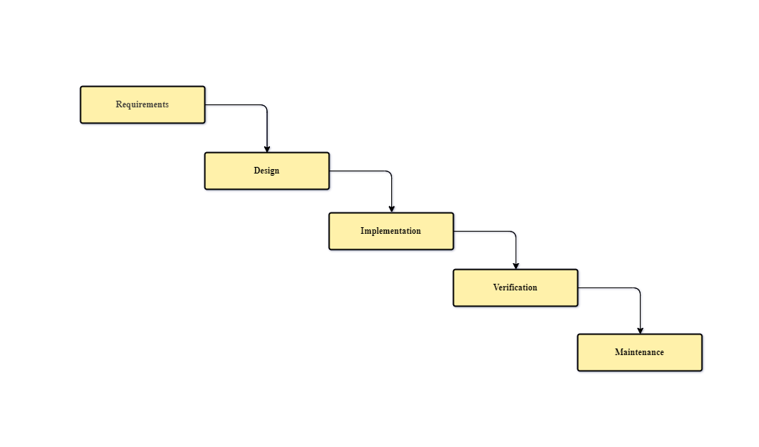Maintenance: as a web developer, I have to check the report from the user and fix the error that has occurred.

*Figure 3: Waterfall Methodology*

## Planning

|  |  |  |  |  |  |  |  |  |  |  |  |  |  |
| --- | --- | --- | --- | --- | --- | --- | --- | --- | --- | --- | --- | --- | --- |
| **Tasks** | **Weeks** | | | | | | | | | | | | |
| 1 | 2 | 3 | 4 | 5 | 6 | 7 | 8 | 9 | 10 | 11 | 12 |
| Get the requirement |  |  |  |  |  |  |  |  |  |  |  |  |
| Define the project scope |  |  |  |  |  |  |  |  |  |  |  |  |
| Wireframing and prototype |  |  |  |  |  |  |  |  |  |  |  |  |
| Implement |  |  |  |  |  |  |  |  |  |  |  |  |
| Testing and Bug Fix |  |  |  |  |  |  |  |  |  |  |  |  |
| Prepare for deployment |  |  |  |  |  |  |  |  |  |  |  |  |

*Table 1: Planning table*

As shown in Table 1, during my twelfth-week internship at ITC, I spent the first week meeting with clients or teacher to gather requirements and define the project scope. After obtaining the project scope, I dedicated two weeks to designing the wireframes and prototypes. Starting from the fourth week, I began implementing the front-end and back-end, which continued until the ninth week. Once I completed the implementation, the client and I conducted testing together to verify the tasks I had accomplished. I spent two weeks resolving bugs and also preparing documents and setting up the environment for deployment and release.

# PROJECT ANALYSIS, CONCEPTION, AND DESIGN

In this section, I begin to identify all the main functional requirements and optional functional requirements of the system.

## Case study of requirement

### Project requirement

The Library Management System is designed with two different user roles, each having specific functions assigned to them. The table below illustrates the roles and their corresponding functions:

|  |  |  |
| --- | --- | --- |
| **User** | **Functional** | **Description** |
| Admin | CRUD user | The admin can create, read, update, and delete users from the system. |
| CRUD candidate | The admin can create, read, update, and delete candidates from the system. |
| CRUD candidate type | The admin can create, read, update, and delete candidate types from the system. |
| Upload data as an Excel file | The admin can upload student information as an Excel file. |
| CRUD department | The admin can create, read, update, and delete departments from the system. |
| CRUD department option | The admin can create, read, update, and delete department options from the system. |
| Generate student card | The admin can generate and export student cards as image. |
| CRUD book | The admin can create, read, update, and delete book information from the system. |
| Admin | CRUD book location | The admin can create, read, update, and delete book locations from the system. |
| Find book | The admin can find a book by item code and update book information |
| Add the book to the department | The admin can add the book to each department easy to manage and find when students borrow. |
| Generate report | The admin can generate reports in Excel and Bar chart |
| Login authentication | The system requires admin for login before using the feature |
| Candidate | Register attendance | Candidates can register attendance when they join the STEM library |

Table 2: Project requirement table

### Non-functional requirement

Non-functional requirements refer to aspects of a system that focus on its qualities and characteristics rather than specific functions. Here are the corrected descriptions of the important non-functional requirements you mentioned:

* Clean code: It is important to ensure that our code is clean and well-organized, facilitating future development by other individuals.
* Performance: Ensuring that the website operates smoothly and efficiently, without any errors, is of utmost importance.
* Stability: The website should run reliably and consistently, without encountering errors, slowdowns, or data loss.
* Security: Strengthening website security is crucial to prevent unauthorized access and data breaches.
* Maintenance: Detecting and addressing errors or mistakes promptly enhances the overall quality and reliability of the application.

## Project analysis

In this section, I will begin utilizing a UML diagram, which is a standardized language used to visually model processes or designs within a software-based system.

### Use case diagram

The use case diagram is important for defining and validating the required features in our application. Each use case box represents an important module that is implemented and contains other features within it. There are two types of users: candidates and admins. Candidates are not required to log in, whereas admins must log in before accessing all functionalities. The following figure is the use case diagram of a “Library Management System”.

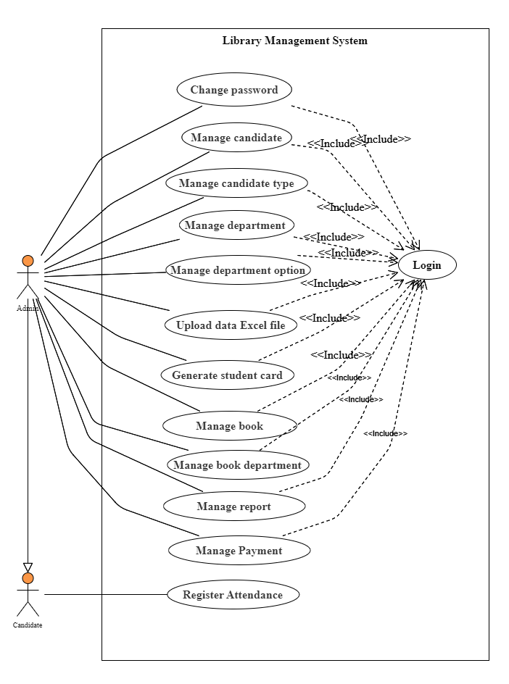

*Figure 4:Use case diagram Library Management System*

### Database schema

After analyzing the main functions of the project, I have identified the required entities and their corresponding categories in the different database tables. By conceptualizing the association entity and the relational model, I can determine the relationships and cardinalities between each table. Furthermore, I can define the conceptual data model by specifying the attributes within each entity. The following figure is a design database schema that can represent the system:

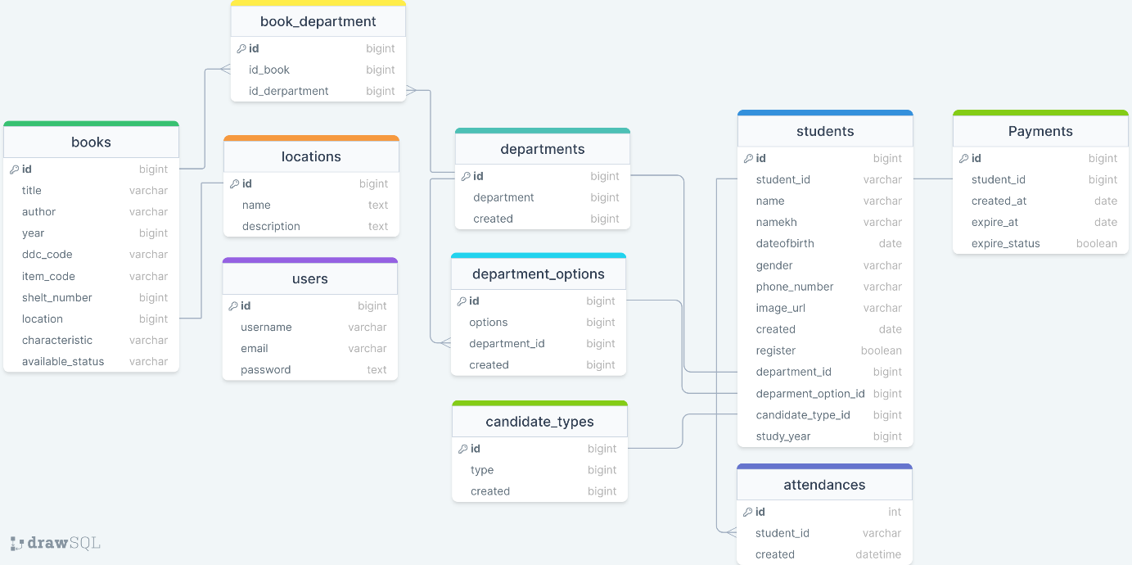

*Figure 5: The database schema*

### Activity diagram

#### Add new user diagram

Figure 6 depicts an activity diagram for the process of creating new candidates by users. To create a new user authentication, administrators are required to first log in to the system. Upon successful login, administrators gain access to the "User Management" feature within their profile. They can then proceed to input the necessary data of the new user and click the "Submit" button to finalize the process. If data valid system going to save and alert snack bar success.

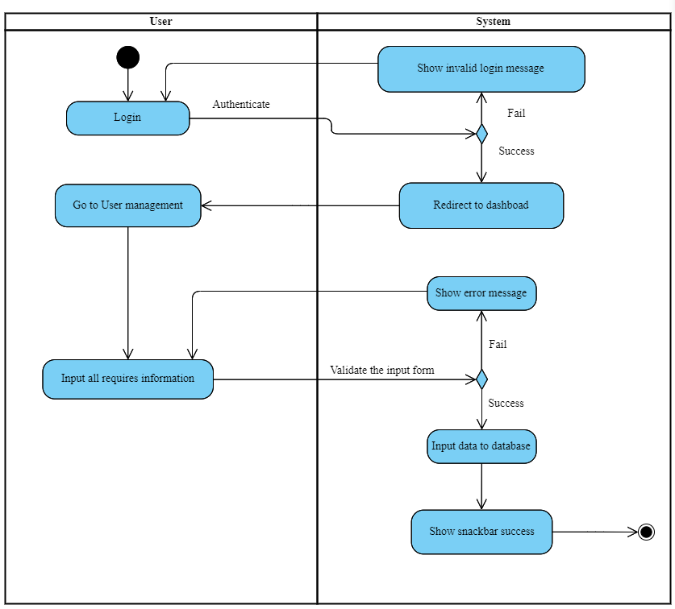

Figure 6: Activity diagram of adding new user

#### Add new candidate diagram

Candidates' information holds significant importance for the system, as it is necessary for users to input their ID and verify their details before joining the library. To create a new candidate, the initial step is for the administrator to log in. Once logged in, the system redirects the administrator to the dashboard. From there, the admin can navigate to the candidate page and click on the "Create candidate" button. Then the user is required to input essential information such as student ID, first name, last name, candidate type, department, department option, and year. Finally, upon clicking "Save," the system will display a success alert if the data is valid; otherwise, it will show an error alert.

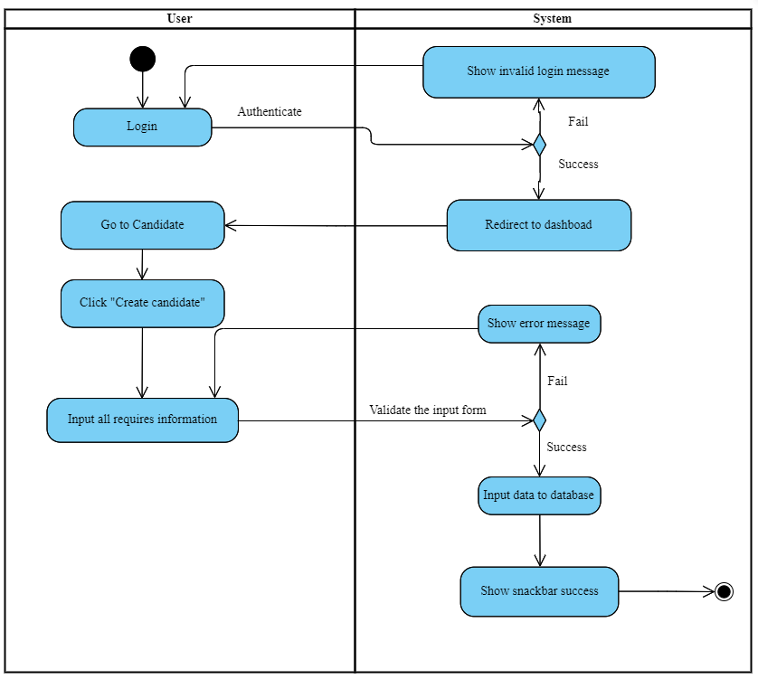

Figure 7: Activity diagram of adding new candidate

#### Register attendance

As shown in Figure 8, the activity diagram illustrates the sequence of steps to register attendance. The first user accesses the system. Before they can proceed with the registration, they need to ensure that their data has already been created as a candidate. To register attendance, users do not need to log in; instead, they simply navigate to the home page and enter their ID. The ID can be entered as a number, for example, "20180328," or input in the full format as "e20180328." Once they have inputted their ID, they can either press "Enter" or click the submit button. After verifying the existence of information associated with the ID, the system will display a success alert. Alternatively, if the ID is not found, the system will display an alert indicating the absence of the ID.

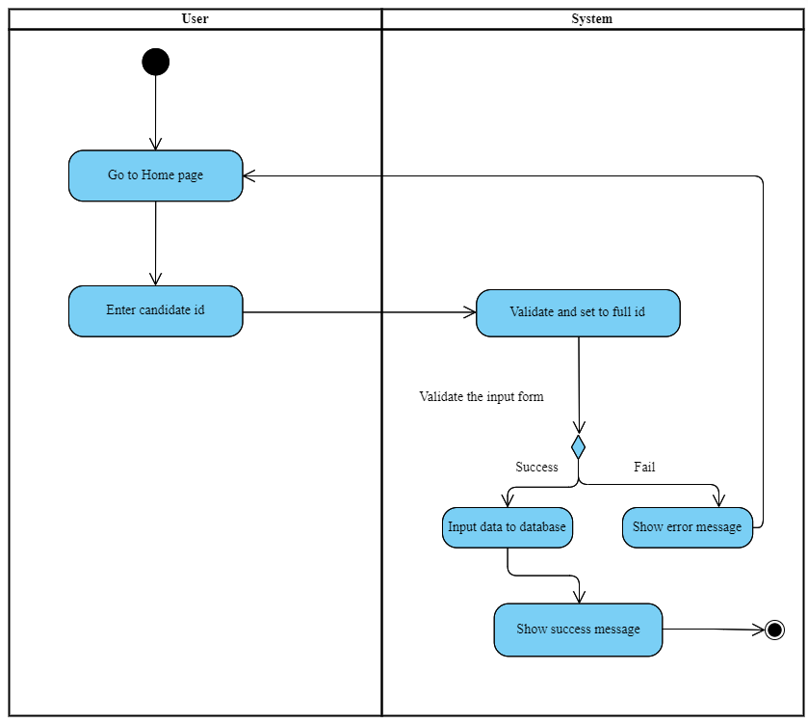

Figure 8: Activity diagram for register attendance

#### Add the book to the department

To add the book to a department, the admin needs to log in to the system first. Once logged in, the user will be redirected to the book page. From there, they can click on the "Settings" option and select the book department. The user should choose the department to which they want to add the book. After selecting the department, the system will redirect them to the book department page, which displays a list of books in that department. To add a book, the user can click on the "Add Book" button, select the book they want to add to the department and click "Submit." Upon submission, the system will insert the data into the database. If the operation is successful, it will display a success message as shown in Figure 9.

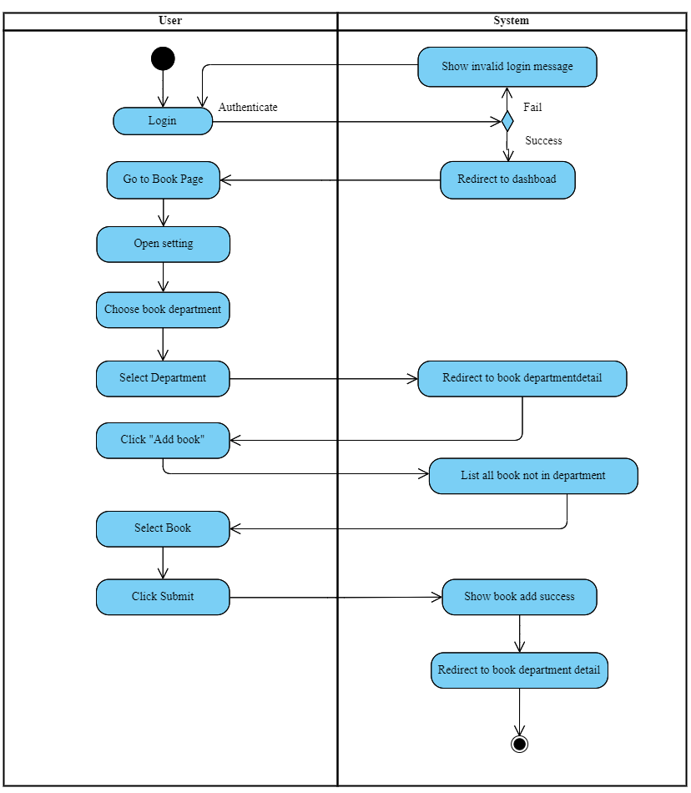

Figure 9: Activity diagram add book to department

# TECHNOLOGY AND DESIGN

## System and Design

### Physical architecture

The physical architecture of the system is described below in Figure 10 and the explanation of each of the following components.

* Client side: Users access the system through a web browser. They interact with the system by sending HTTP requests to the web server.
* Web Server: The web server receives the HTTP requests from clients and processes them. It uses Node.js, which is a JavaScript runtime environment, along with an instructs framework and makes communication with the database server.
* Database Server (MYSQL): This component is responsible for storing and managing the data for the system. MYSQL is a popular open-source relational database management system. When the web server receives a request that requires data retrieval or modification, it generates the corresponding SQL query to interact with the MYSQL database server. The query is then executed on the database server, and the results are sent back to the web server.

In summary, the client accesses the system via a web browser and sends HTTP requests to the web server. The web server processes these requests using Node.js and an instructs framework, generating JSP files for the web view. The database server (MYSQL) stores and manages the system's data, and the web server communicates with the database server by generating and executing SQL queries.

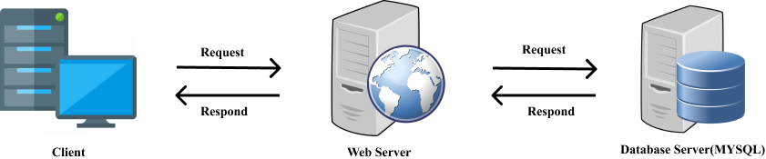

Figure 10: Physical architecture of application

### Logical architecture

The logical architecture as shown in Figure 11 describes the idea of how the structs framework uses MVC structure to build the web application with Node JS as API and Vue JS as Front-end.

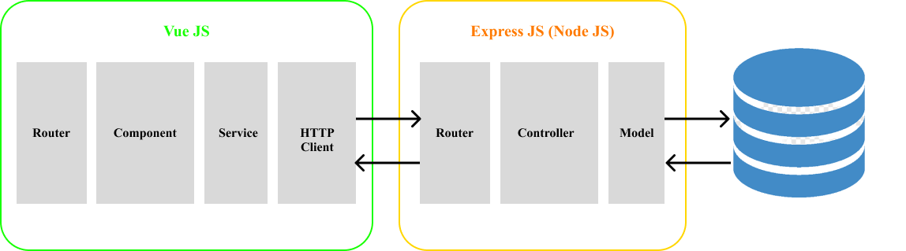

Figure 11: Logical architecture of application

* Node.js is a runtime environment built on the V8 JavaScript engine, which allows you to run JavaScript on the server side. It follows a single-threaded, event-driven, and non-blocking I/O model, making it highly scalable and efficient for building server-side applications. The logical architecture of a Node.js application typically consists of the following components:
  + Routes: define the API endpoint and handle incoming HTTP requests
  + Controller: contain the business logic for processing requests are generating response
  + Models: Represent the data structure and interact with the database
* Vue.js is a JavaScript framework for building user interfaces. It focuses on the view layer of the application and provides tools for building reactive and component-based UIs. The logical architecture of a Vue.js application typically includes the following components:
  + Route: define the end point of the page
  + View component: for displaying the user interface when an incoming request from the router
  + Service: can communicate with external APIs or backend services through HTTP requests or WebSocket connections.

## Framework and Technology

**Node JS** [1] is an open-source, server-side runtime environment that allows developers to run JavaScript code outside of a web browser. It is built on the Chrome V8 JavaScript engine and provides an event-driven, non-blocking I/O model, making it efficient and lightweight for building scalable network applications.



Figure 12: Node JS logo

**HTML** [2] is used to put the structure of a website together for documents designed to be displayed in a web browser. CSS [3] acts as makeup for HTML where it improves the user interface such as the color and layout of a website structure build with HTML. JavaScript [4] is a full-on programming language that adds interactivity and functionality to a website.



Figure 13: HTML, CSS, and Javascript

**Vue JS** [5] is an open-source JavaScript framework for building user interfaces (UIs). It is often referred to as a progressive framework because it can be incrementally adopted into existing projects or used to build full-fledged single-page applications (SPAs). Vue JS focuses on the view layer of an application and aims to simplify the development of interactive web interfaces. It provides a set of tools and features that enable developers to create reusable components and efficiently manage the state and behavior of their applications.



Figure 14: Vue JS logo

**Vuetify** [6] is a popular open-source UI component framework for Vue.js. It provides a set of pre-styled, reusable UI components that developers can easily integrate into their Vue.js applications. Vuetify follows the Material Design guidelines, offering a modern and visually appealing UI design.



Figure 15: Vuetify logo

**MYSQL** [7] is one of the most popular and widely used open-source relational database management systems (RDBMS). There are several reasons why MySQL is commonly used and its importance is known for its ease of installation, configuration, and management. It has a straightforward setup process and provides user-friendly command-line and graphical interfaces, making it accessible to developers of all skill levels.



Figure 16: MYSQL logo

## Version control system

In the programming field such as web development, vision control is a type of practice that tracks and provides control over changes to source code. I chose **GitHub** [8] for project version controls. For my project, version control is very important because it helps me to manage my project. I can store my source code every time I complete any functionality. Easy to get it back when writing something wrong in my project. Additionally, I can create an additional branch to store our code. Because it my project there are 3 main folder projects is API, admin panel, and candidate panel.



Figure 17: GitHub logo

## Tools

**IntelliJ IDEA** [9] is a type of the best IDE. Integrated Development Environment is Intelligent Coding Assistance for web development because it provides on-the-fly error prevention, best auto completion and code refactoring, zero configuration debugging, and an extended HTML, CSS, and JavaScript editor. Intellij has many features but the best three features are interesting and we decide to use them.



Figure 18: InterlliJ logo

**Visual Studio Code** [10] is a standalone source code editor that runs on Windows, macOS, and Linus. The top pick for Website development, with more extension support. I used it because it works fast for my computer and can create and compile the project like other tools.



Figure 19: VS code logo

**Postman** [11] is an API platform for developers to design, build, test, and iterate their APIs. It is an HTTP client that tests HTTP requests, utilizing a graphical user interface, through which we obtain different types of responses that need to be subsequently validated. I used Postman for testing project API after I build it completely in each functionality before, I integrate it with the front end. When we have the swagger configuration in our project, we just import the link of our API description, it generates all the requests for us to test easily.



Figure 20: Postman logo

**XAMPP Control panel** [12] is a popular software package that simplifies the setup and management of a local development environment for web applications. It includes Apache HTTP Server, MySQL database, PHP, and Perl, allowing developers to easily run and test their web projects on their computers before deploying them to a live server.



Figure 21: XAMPP control panel logo

**Heidi SQL** [13] is an administration MYSQL tool. We use it to design, back up, restored, and manage databases. It works well and easy to manage the data in my database. It can generate queries for me to select, create, update, and delete. An important control on data is that we can back up the data as a file from the tool and we can restore it, so our data is secure.



Figure 22: Heidi SQL logo

# PROJECT IMPLEMENTATION

This section, detail the implementation of the project during the internship. I explain how to set up tools and technology, project implementation, and installment.

## Project setup

### Environment setup

To set up the required environment and tools for your project, follow these steps:

* Install Node JS version 16.13.2
* Install the IDE. In my case, I choose IntelliJ IDEA and Visual Studio Code for the code editor.
* Install the Postman for testing API
* Install the XAMPP control panel and Heidi SQL to manage the database

### Project initialization

#### Create a project with Node JS

After setting up all of the required environments, I used the command line to initialize the project and install the libraries that I need to use. I used the command "npm init -y" to initialize the project, and then I used "npm install library" to install the required library onto my system. After initializing and running the project, we can still access the library by using the same command. A sample of the initial project with Node JS shows in Figure 23.

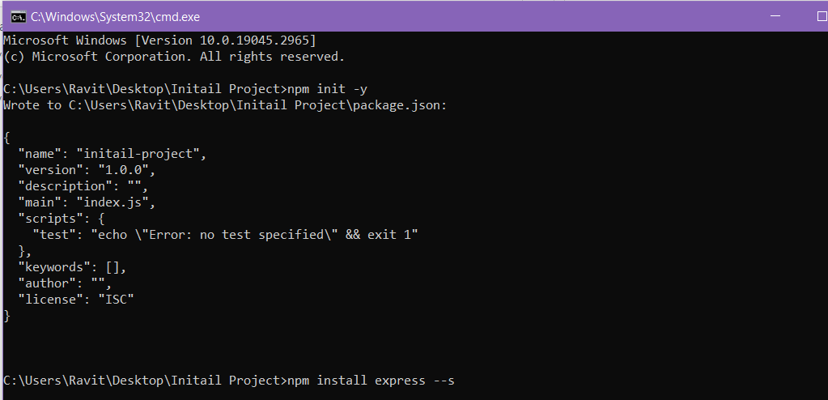

Figure 23: Node JS initial project

#### Create Vue JS application

To develop a Vue.js front-end application, we will need to have Node.js installed, as it provides the runtime environment for handling data communication. Before creating a Vue.js project, you must install the Vue CLI by running the command “npm install -g @vue/cli” This command will globally install the Vue CLI package (@vue/cli) on your system. The -g flag ensures that the package is installed globally, allowing you to access it from any directory in your command line. Once the installation is complete, you can create a new Vue.js application by running the following command “vue create project-name”. This command will initiate the project creation process and prompt you to choose a preset. You can select the default preset, manually select features, or choose a saved preset as shown in Figure 24:

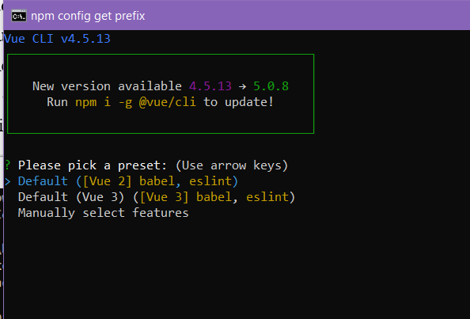

Figure 24: Vue creates an application

## Project structure

### Node JS project structure

The application structure in Node JS is the structure of folders, and files included in a project. When we create the project, we will get an overview of the application structure as shown in Figure 25.

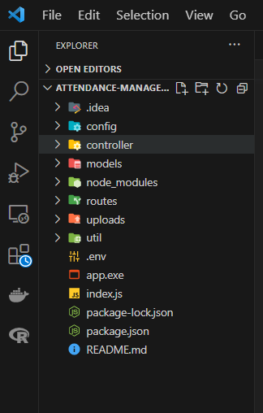

Figure 25: Node JS project structure

Node JS project structure:

* Config: This directory typically contains configuration files for the application. It stores config for database base or security.
* Controller: controller directory house the class and method logic for handling incoming requests from the router and generating the appropriate response that it gets from model and return to the router.
* Models: this directory is where define the application data models and often interacts with a database or other data source. Its communicates with the database and responds to the controller when the controller request.
* Router: the router directory contains the route definition for the application. It specifies how different HTTP requests are mapped to the corresponding controller function. It is use to send a request to a controller and receive a response and response to http request.
* Uploads: the directory store image that uploads and shares to the network for access. By get uploading image we need to config it by putting code you provided sets up two static file serving middleware for easy request.
* Util: the directory stores helper functions that can be used across the application, and it is most commonly used in controllers.

### Vue JS project structure

Vue JS structure is already set up by default when we initiated the project. The directory that we need to structure is in the src directory. The following is the project directory that I have set up:

* + - Assets: the directory is used to store images, fonts, or stylesheets that are required in the application that mostly call to use into views and components.
    - Components: the components directory stores reusable building block that use in the Views directory.
    - Views: the views directory is a store page component for display in a different view and have return the value to route for response to the client.
    - Router: this directory contains the Vue Router configuration files. It allows up to control what page we need to show in the path.
    - Services: this directory contains the service that communicates with API that uses in all pages that need to load data from API. It is mostly called in the view, specifically in JavaScript, as JavaScript is used to fetch and prepare data for display.
    - Plugin: is store the new library that needs to be set up example Apex chart

The project directory is very important and I will improve or update it in the future when the project increase more functionality or feature.

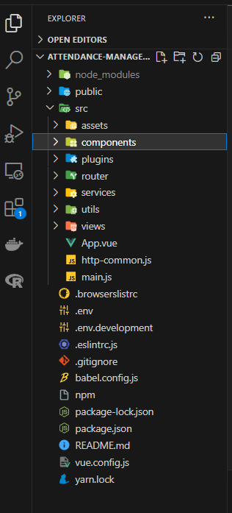

Figure 26: Vue JS project structure

## Project implement

### Login authentication and logout process

Login and logout are two of the most important functionalities of a system since they are used for security purposes to prevent unauthorized access to our web application and unauthorized collection of our data. The first stage of the procedure occurs when a user tries to enter the URL for the dashboard of the website. At this point, the system checks the cookies and session on the browser using the Java action class to determine if the user is already logged in or not.

If the browser's cookies or session already contain the user's information, such as their ID and email, the system will forward the user to the dashboard page or the home page of the website. Conversely, if the cookies and session of the browser do not contain any user information, the system will route the user to the login page. In this case, the user has to input the correct email and password that are already registered in the system and stored in the database.

The user authentication operation works in a few steps, as shown in Figure 27. Firstly, I need to check the session to determine if the user is null or not. If the user is null, the system allows the user to input their information. Once the user completes entering their information, I need to query the data from the database by retrieving the user with the input email.

The encrypted password of the user stored in the database is in the form of a hashed password, encrypted using a specific library. To verify whether the password inputted by the user is correct or not, I have to use a built-in function from this library called "checkPassword(plainPassword, hashedPassword)". Here, plain password refers to the password inputted by the user, and hashed password is the password of the user retrieved from the database. If both passwords match, the function will return true; otherwise, it will return false.

When the user is retrieved from the database, it means that the login is successful and the input password matches the password stored in the database. In this case, the login is considered successful, and the route will be forwarded to the dashboard page. However, if the passwords do not match, an invalid login message will be displayed to the user, and the system will allow them to enter their information again.

The logout operation occurs when the user clicks the logout button. It involves clearing the cookies and invalidating the session of the logged-in user in the browser. Finally, the user will be routed to the login page.

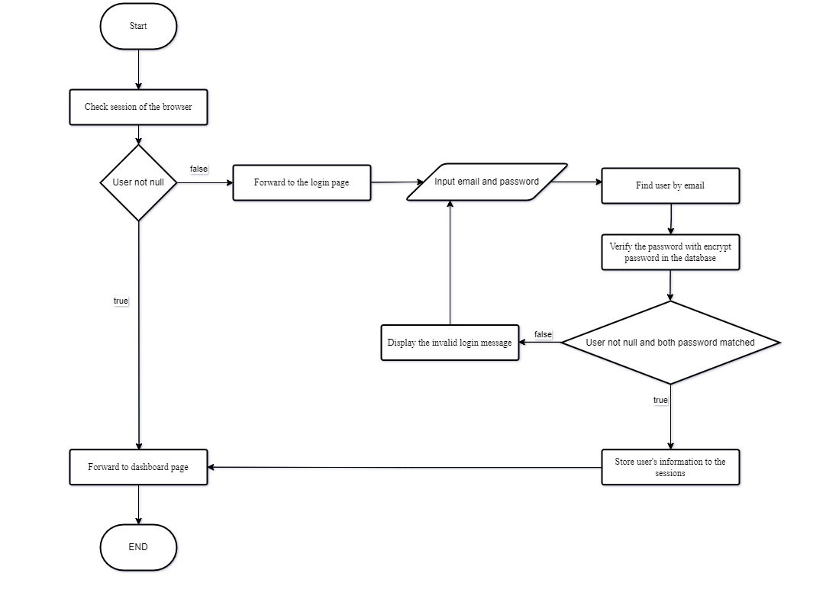

Figure 27: Login authentication flowchart

### Create a new candidate

One of the core functions of this project is to allow the admin user to manage candidates. This means that the user should be able to create candidates to perform other functions such as payment and attendance.

In Figure 28, to create a new candidate, the user needs to first log into the system. After logging in, the user can select the "Create candidate" button. They will then be prompted to enter all the required information about the candidate into the respective fields.

There is a special input box for the student ID, which must be unique. If the entered student ID already exists, the system will query the existing candidate data and allow the user to update their information. On the other hand, if the student ID is new, the user needs to input the required information, and the system will generate the year_department for the candidate. Once the data storage process is complete, the system will redirect the user to the candidate list page.

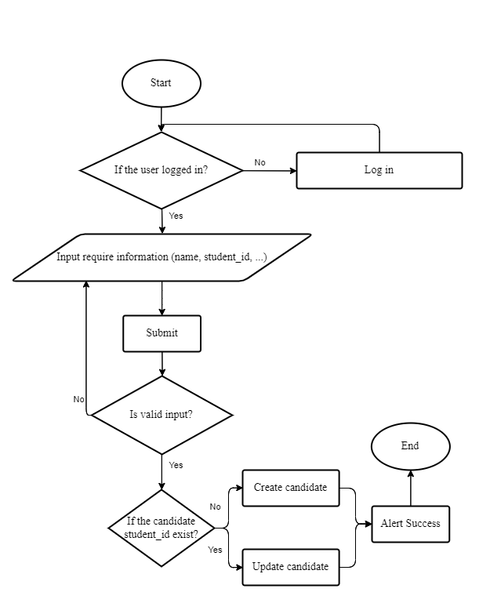

Figure 28: Create a candidate flow chart

### Create a new book

Another main function of the project is to enable the admin user to manage books and their locations, making it easy for candidates to find and borrow them.

To create a new book, the user needs to log into the system and go to the question page. From there, they can select the "Create book" button. The system will prompt the user to input the required information for the book. Additionally, the user will need to specify the book's location and indicate whether it is available or not.

Once the user has entered the required information, they can click on "Save" to store the book information in the database.

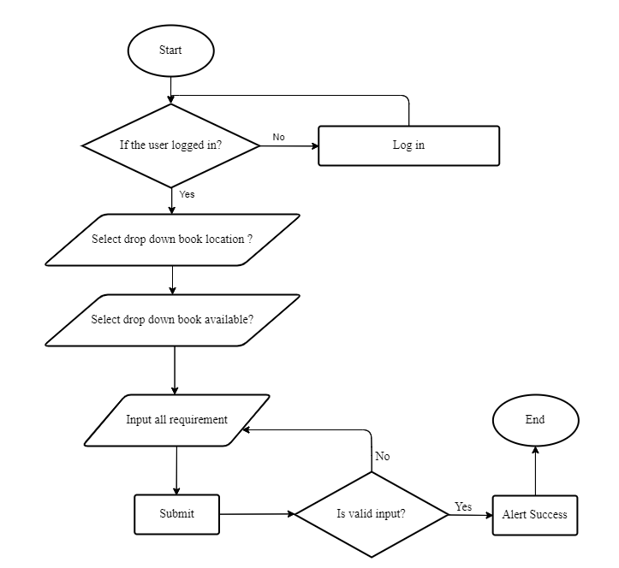

Figure 29: Create a book flow chart

### Add multiple books and department

The functionality of adding multiple books to a department is essential for efficient management and easy access to book information based on the student's department. To add multiple books to a department, the user needs to log in to the system, navigate to the book page, and select the settings option. From there, they can go to the book department section. On the book department page, the user can select the desired department. The system will then redirect them to the book department details page, which lists the books available in that department.

Once on the book department details page, the user can click on the "Add book" button. A dialog box will appear, displaying a list of books that have not yet been added to the department. The user can select the desired book(s) and click "Submit." The system will then store this information in the database.

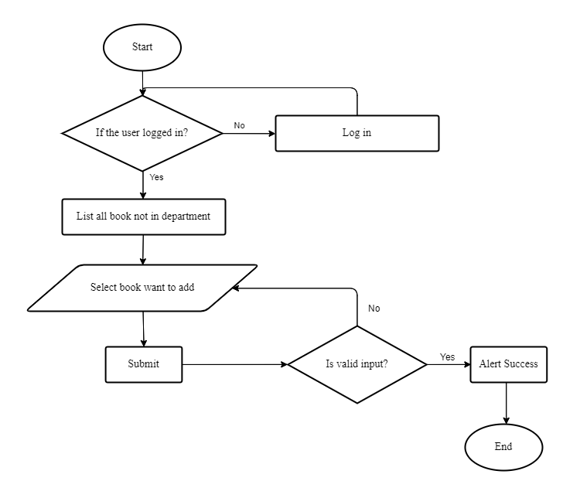

Figure 30: Add books to the department flow chart

### Access Control with Open Policy Agent

Access control is a critical aspect of maintaining the security and integrity of systems and data. It ensures that only authorized individuals or entities can access and perform actions on sensitive resources. Open Policy Agent (OPA) is a popular open-source policy engine that provides a flexible and scalable approach to access control. When using OPA as a middleware to manage authentication, users need to add their role and specify the action they want to perform when accessing a particular route. We will then verify and allow them to access the route path and execute the corresponding logic function in the controller. For process OPA we need to have file .rego that already writes logic and convert to bundle.tar.gz by command “opa build -t wasm -e auth/allow ./middleware/example.rego” and then convert to file policy.wasm by command “tar -xzf ./bundle.tar.gz /policy.wasm”.

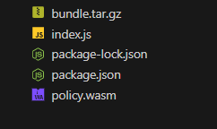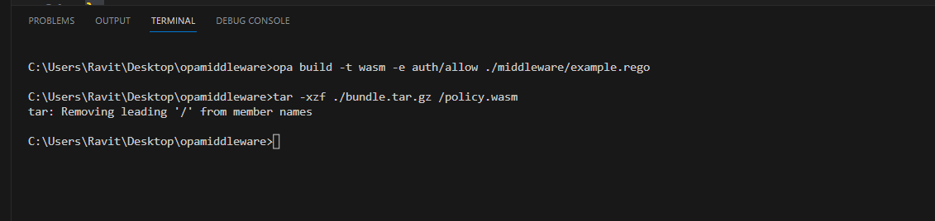

Figure 31: Build the Web Assembly OPA

### Import student information from Excel file

Importing student information from an Excel file is a useful feature that can assist administrators in creating multiple candidates at once. Figure 32 illustrates the process of creating multiple candidates by inputting information into an Excel file. First, the user must log in to the system and navigate to the candidate page. Then, they should open the settings menu and select "Upload Data from Excel." On the upload information page, the user is required to provide a header file in Excel format that adheres to the predetermined structure set by the developer. The user can then populate the Excel file with the necessary student information. User need to user the file already updated to uploaded to the system, it undergoes a verification process. If a student_id already exists, the system will skip the corresponding student information. Otherwise, the system will store the student information in the database. This process repeats until the end of the row is reached.

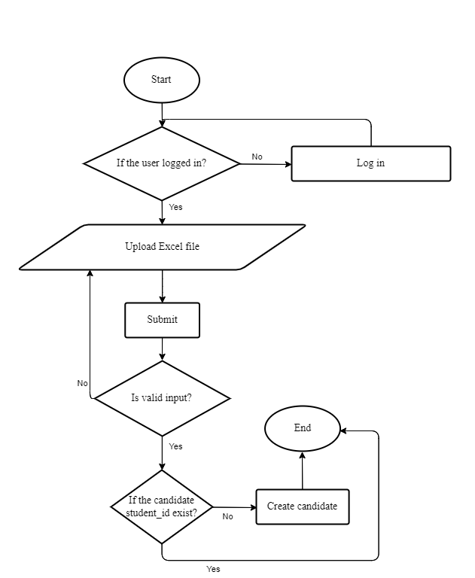

Figure : Import student information by Excel file

### Export report as Excel file

Exporting reports as Excel is a common feature in most systems. To enable this functionality, the system relies on a library called "kendo-vue-excel-export." This library is specifically designed to export data into Excel format and is regularly updated to ensure compatibility with the latest Excel versions. Before exporting a report as an Excel file, it is essential to prepare the header and data for the export process. Once the preparation is complete, the method saveExcel can be called, passing the relevant information as parameters. This method generates the Excel file, which can then be obtained for further use. The following figure is the sample code of the saveExcel file.

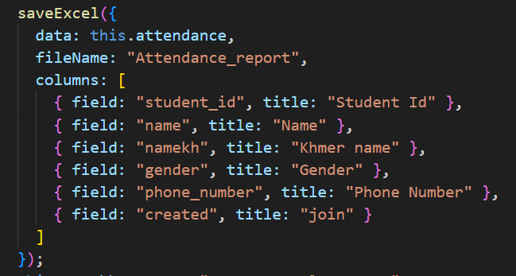

Figure : Save Excel file

### Export image of student card

Exporting student library cards as images is a valuable feature for a system. When exporting student cards, the resolution of the exported image is crucial. To initiate the export process, it is necessary to have a reference to the designed card template. Once the reference is obtained, options need to be prepared to ensure the exported image is of high quality. To create the output image, the system can utilize the "html2canvas" library. This library enables capturing the visual representation of HTML elements, such as the student card. After creating the output using html2canvas, a link can be generated to store the image. Finally, the system can facilitate the download of the image by providing a means to access and save it from the link that has been set up. This way, users can obtain the exported student library card as an image file. The following figure is a sample option that I have used to export images with good resolution

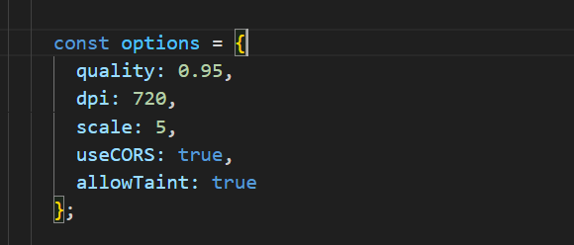

Figure : Option for export image

# CONCLUSION

The internship at ITC has truly helped me develop both my technical skills and my soft skills. Although I encountered a few difficulties during this internship, I was able to overcome them promptly.

## Complete and uncompleted task

After finishing the internship program at ITC, the result of the project Library Management System will be illustrated in the table below:

|  |  |  |
| --- | --- | --- |
| **Task** | **Completed** | **Uncompleted** |
| Login authentication | ü |  |
| Register attendance | ü |  |
| CRUD candidate | ü |  |
| CRUD candidate type | ü |  |
| CRUD department | ü |  |
| CRUD department option | ü |  |
| CRUD book | ü |  |
| CRUD book location | ü |  |
| Add the book to the department | ü |  |
| Generate report excel | ü |  |
| Generate report bar chart | ü |  |
| Upload candidate by Excel file | ü |  |
| Change password | ü |  |
| Generate an image student card | ü |  |
| Generate image top ten register | ü |  |
| Apply Open Policy Agent |  | û |

Table 3: Project result table

## Strong point

In this internship program, I have worked hard on the project and have successfully conducted so many strong points as follows:

* Comprehensible and attractive UI
* Authentication and validation work efficiently
* Most of the functionalities are very responsive
* Loading speed is very fast
* Performance is acceptable
* Less step to archive each operation

## Weak point

Even though the system was developed with many strong points, there are still some weak points that need improvement and further development. These include:

* Open Policy Agent access control with a user interface: Enhancing the access control system by integrating it with a user-friendly interface for easier management and configuration.
* Efficient storage of user file images and faster processing of Excel files
* Enhancing configuration options to facilitate user-friendly configuration

## Difficulties

During this internship, I encountered numerous difficulties and problems, with the primary issue being the limitation of work analytics. I have had to learn and adapt to a new project that is entirely unfamiliar to me. This marks the first time I have embarked on solo development, and I find it exceedingly challenging. When faced with problems, I often have to rely solely on my solutions, which may not always yield satisfactory results. As a result, I frequently find myself seeking assistance from my project advisor to make necessary changes and seek guidance. Regarding many issues during the implementation, it is also a valuable experience that I get from this internship.

## Experience

Honestly, three months of internship is quite a short period, and acquiring knowledge. Following are experiences that I have received from my internship including soft skills and hard skills:

* The working process with the client
* communication with the client
* Apply new technology
* Time management
* Deal with trouble
* Self-learning and doing research
* Solve the problem with my idea
* Working independence

## Perspective

If I have the opportunity to continue working on this project, I would like to address a specific feature that has not yet satisfied the users. Additionally, I would like to add new features that would be useful for the library. There are several functionalities that I should improve and build in the future:

* Update open policy agent to make can control with UI
* Upgrade the front end to improve user friendly
* Improve the system can upload 10000 data with a faster
* Enable to save big files with can link images in Excel file
* Make the system more secure
* Make project structure better and consistency key

## Summary

The internship is finally very vital for students to gain social and academic skills. After finishing the internship, I become fully aware of the fact that the knowledge we have learned in class is like a foundation for us to adapt to every new thing that we need in our future job. Furthermore, this internship program allows me to get more experience, I can practice the use of the methodology of project management and how to use it properly. I am sure that all of these experiences will be the most valuable for my future career.

# REFERENCES

[1] Introduction to Node JS. (n.d.). Introduction to Node JS. Retrieved June 10, 2023, from <https://nodejs.org/en>

[2] Introduction to HTML. (n.d.). Introduction to HTML. Retrieved June 10, 2023, from <https://www.w3schools.com/html/html_intro.asp>

[3] CSS Introduction. (n.d.). Retrieved June 10, 2023, from <https://www.w3schools.com/css/css_intro.asp>

[4] JavaScript.com. (n.d.). Retrieved June 10, 2023, from <https://www.javascript.com/>

[5] VueJS.org. (n.d.). Retrieved June 10, 2023, from <https://vuejs.org/>

[6] Vuetifyjs.com. (n.d.). Retrieved June 10, 2023, from <https://vuetifyjs.com/en/getting-started/installation/>

[7] Mysql.com. (n.d.). Retrieved June 10, 2023, from <https://www.mysql.com/>

[8] Github.com. (n.d.). Retrieved June 10, 2023, from <https://docs.github.com/en>

[9] IntelliJ IDEA: The Capable & Ergonomic Java IDE by JetBrains. (n.d.). JetBrains. Retrieved June 10, 2023, from <https://www.jetbrains.com/idea/>

[10] Visual Studio Code—Code Editing. Redefined. (n.d.). Retrieved June 10, 2023, from <https://code.visualstudio.com/>

[11] Postman API Platform | Sign Up for Free. (n.d.). Postman. Retrieved June 10, 2023, from <https://www.postman.com/>

[12] Apachefriends.com. (n.d.). Xampp. Retrieved June 10, 2023, from <https://www.apachefriends.org/index.html>

[13] Heidisql.com. (n.d.). HeidiSQL. Retrieved June 10, 2023, from <https://www.heidisql.com/>

# ANNEXES

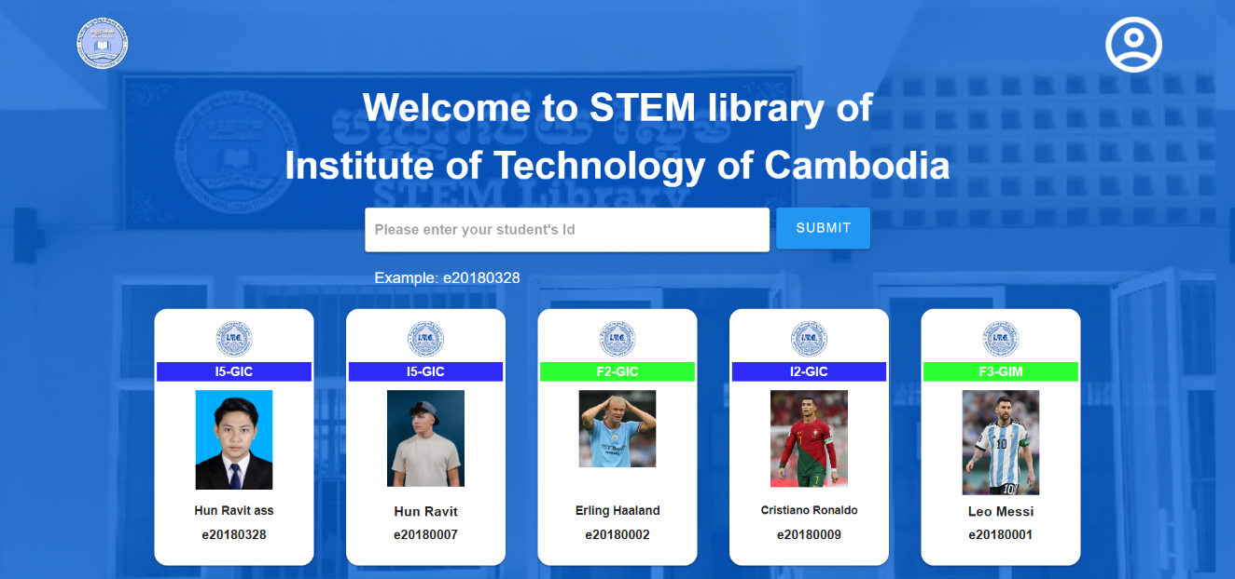

Figure : Register Page

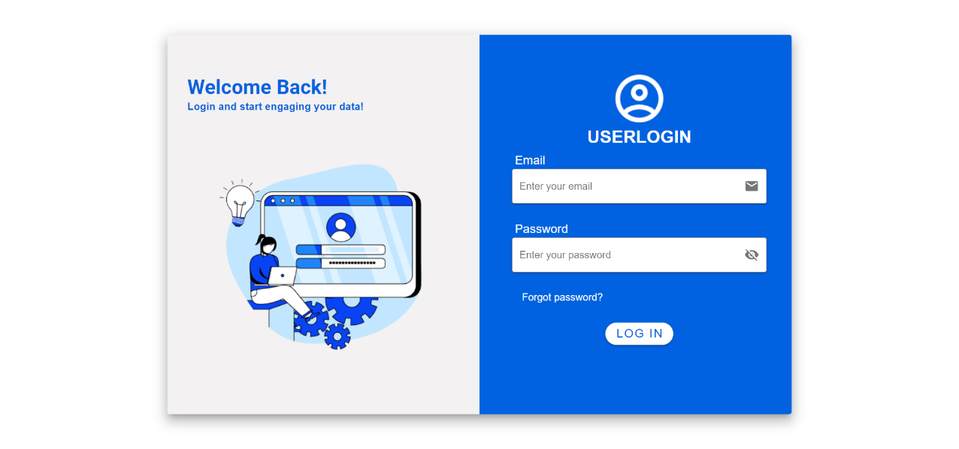

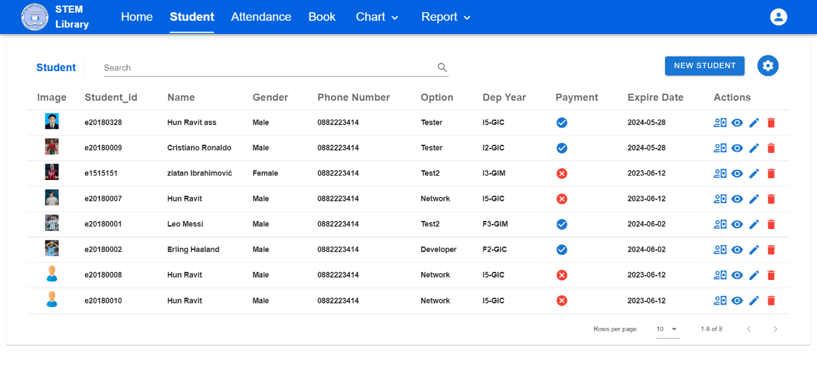Figure : Login page

Figure : Student Page

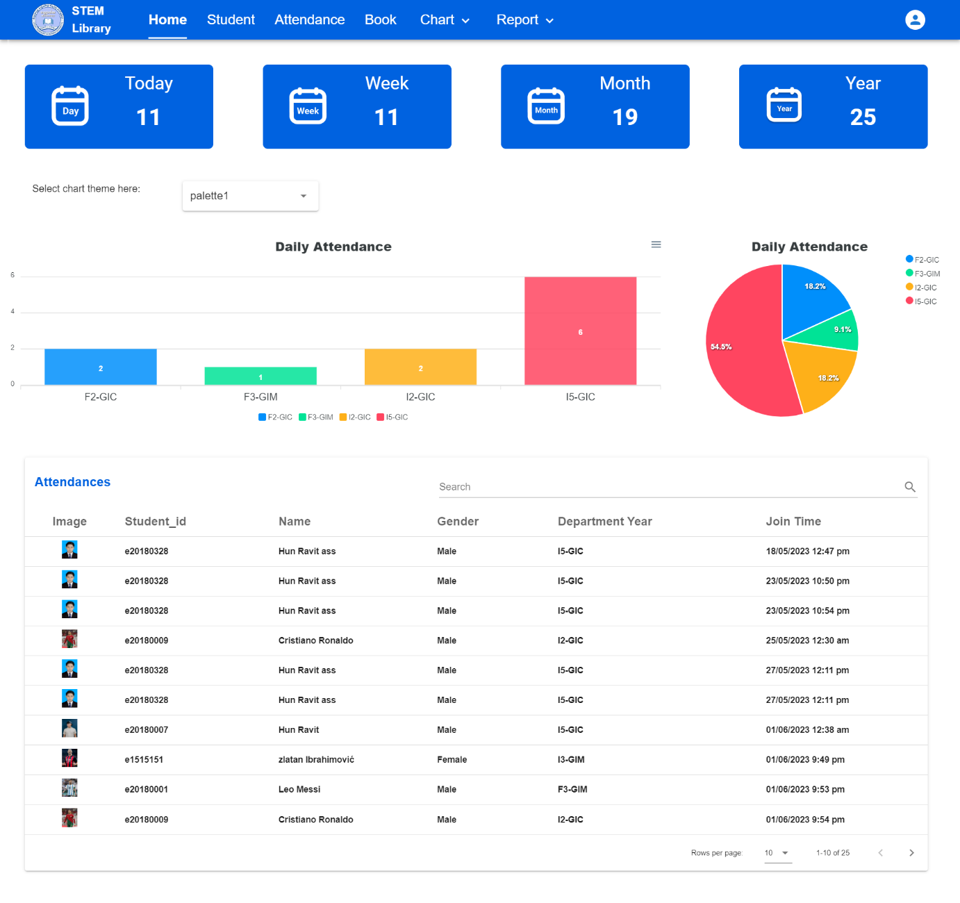

Figure : Home page

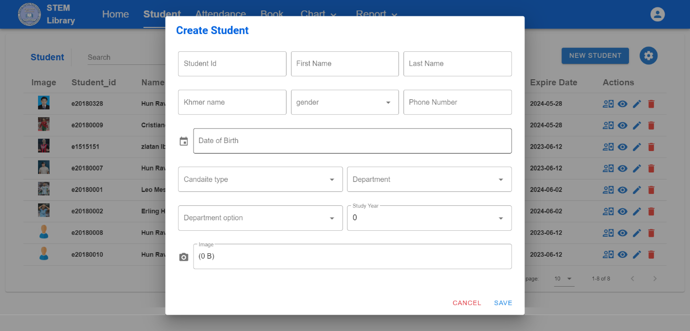

Figure : Create student dialog

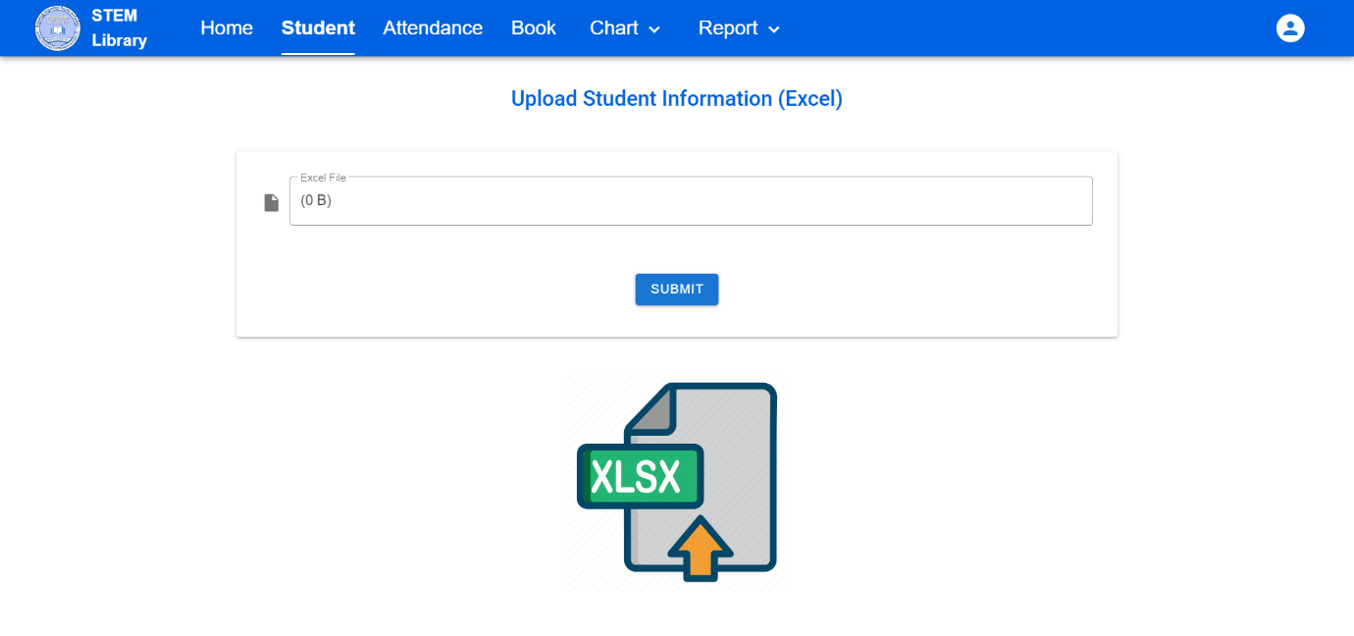

Figure : Upload data Excel page

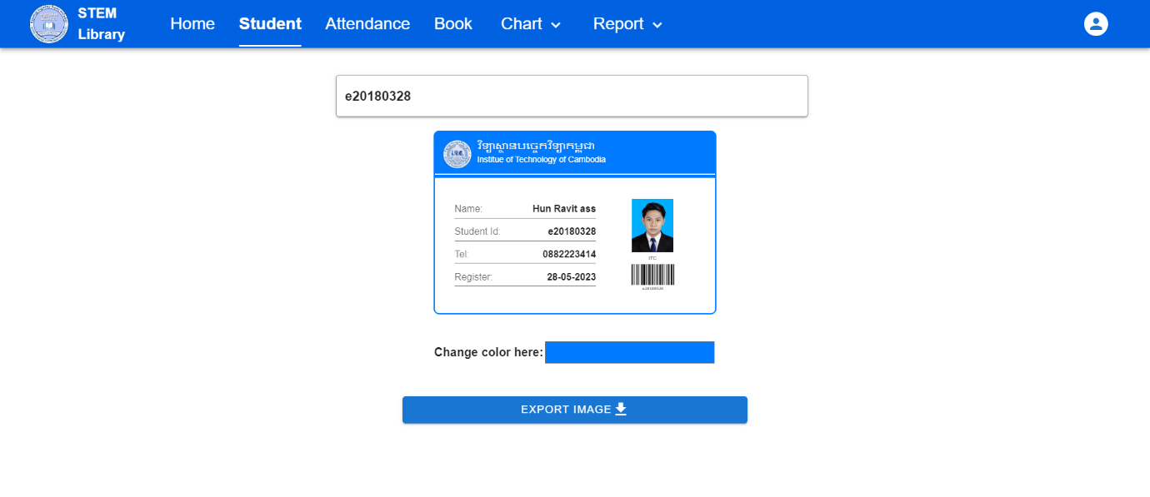

Figure : Generate student card page



Figure : Generate the top ten register page

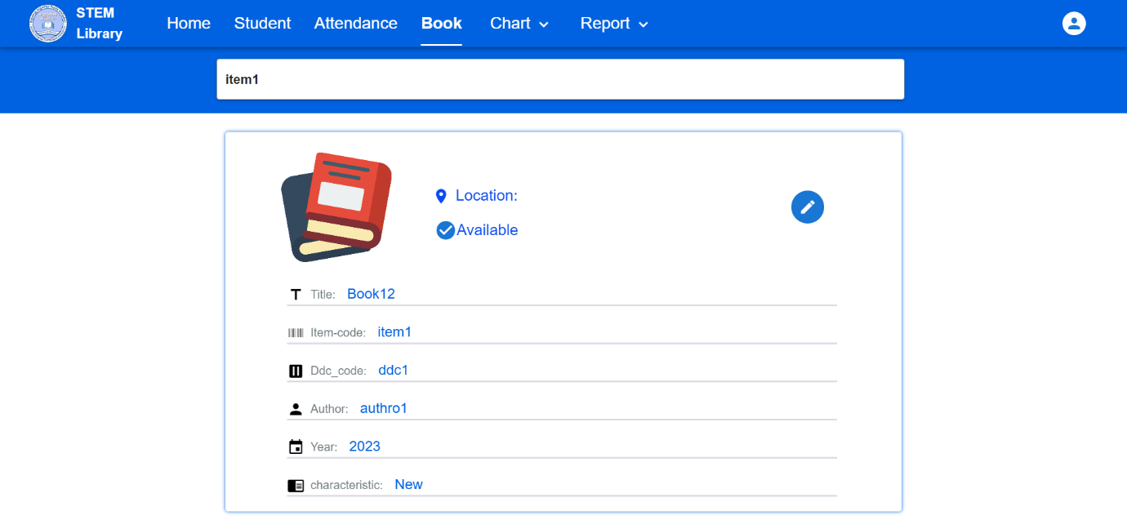

Figure : Book find the page

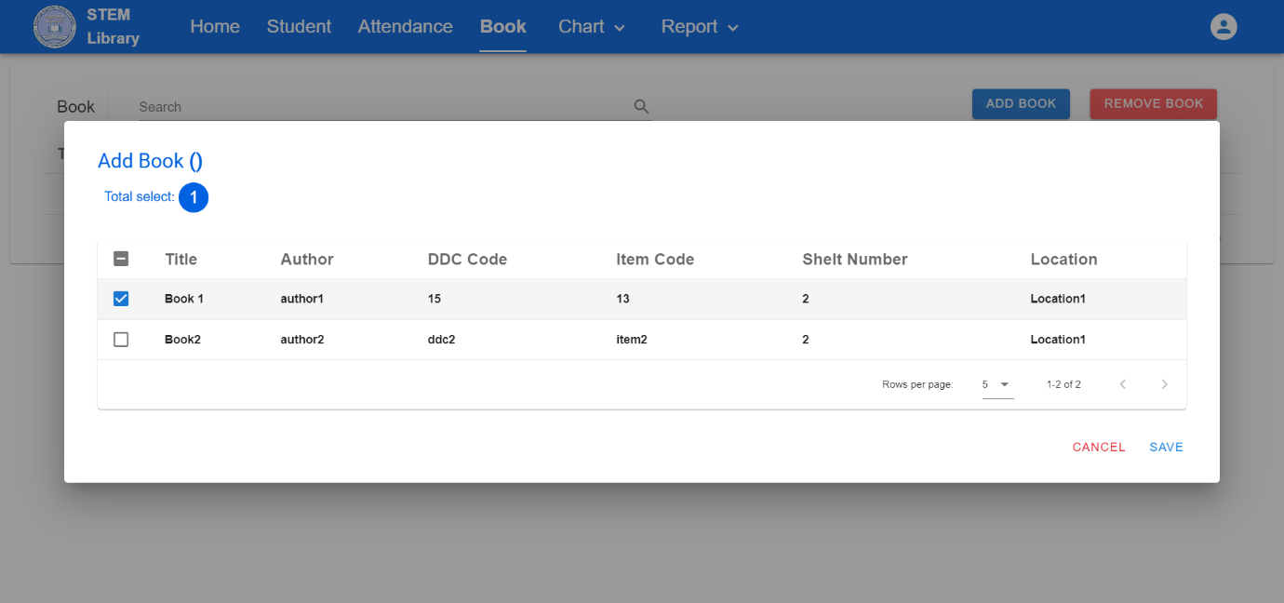

Figure : Add book to department dialog

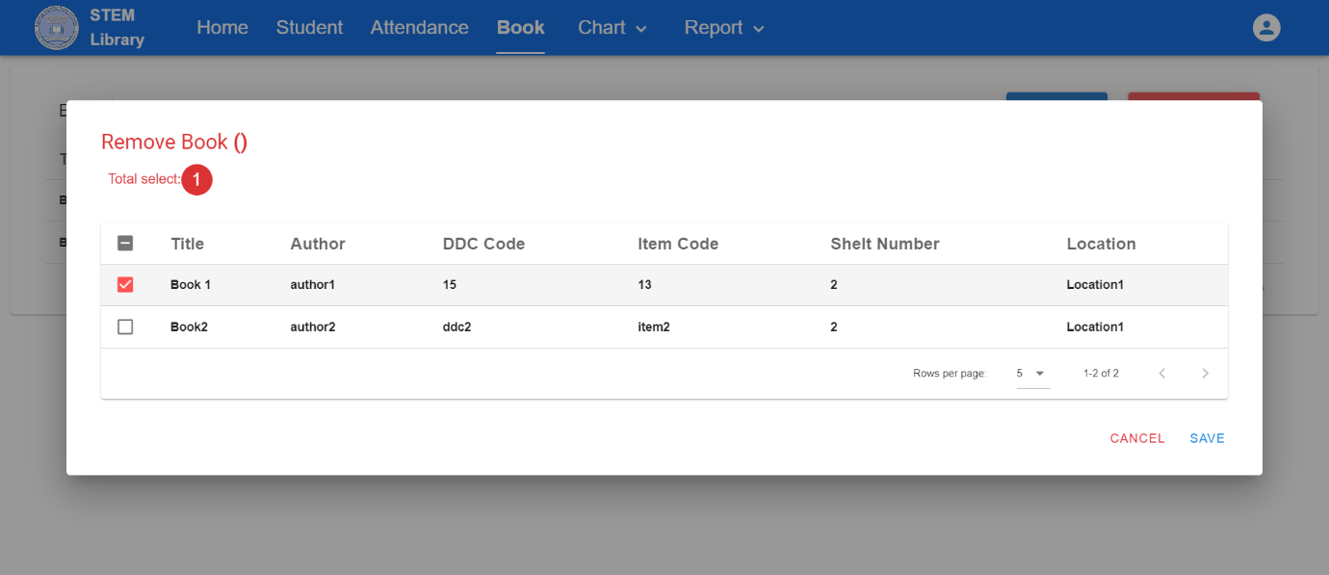

Figure : Remove book from department dialog

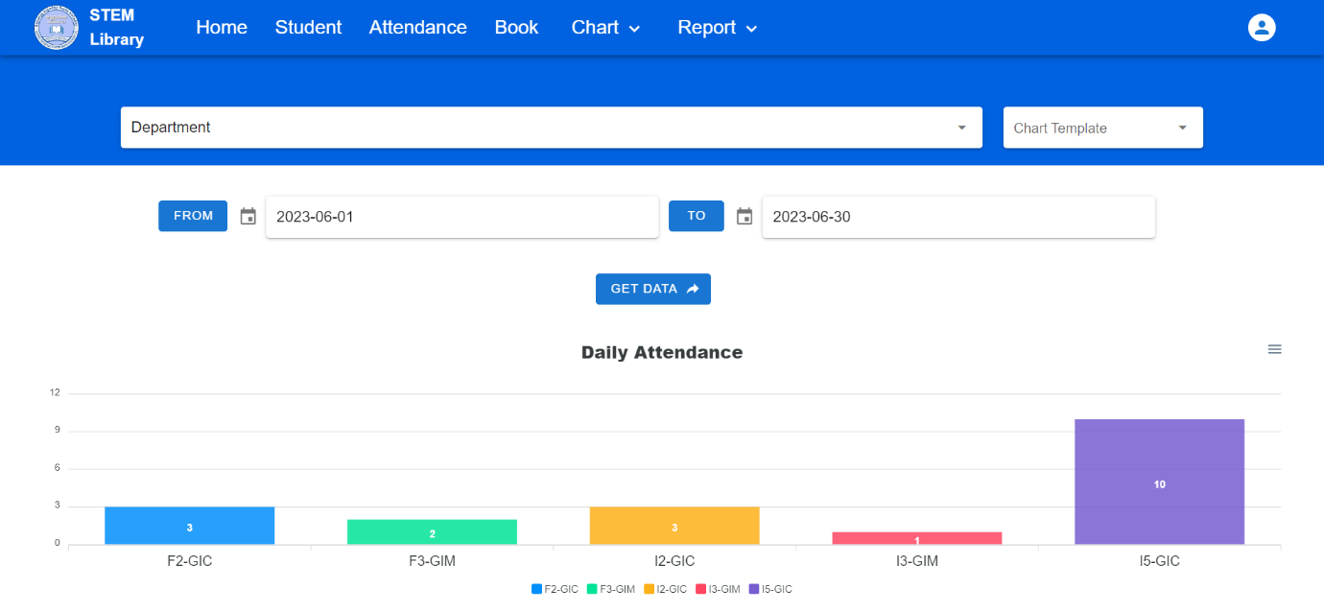

Figure : Attendance report bar chart

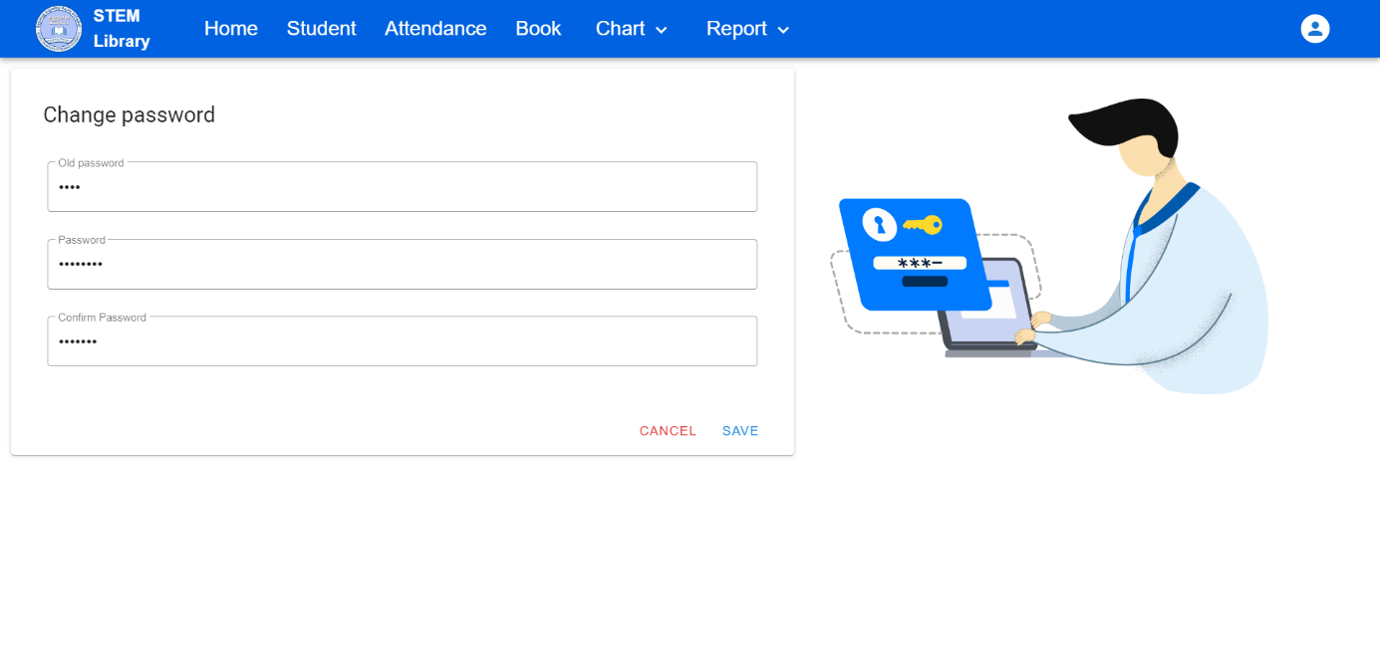

Figure : Change the Password page

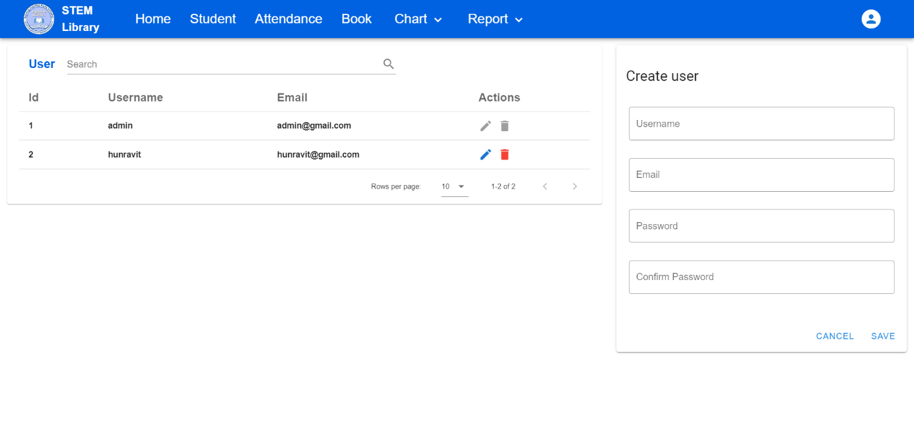

Figure : User Manager page